EPA GREENHOUSE GAS EMISSIONS 2010

SUNSHINE CANYON LANDFILL
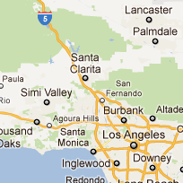  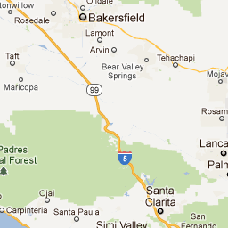  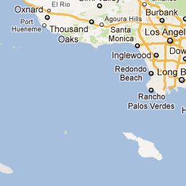  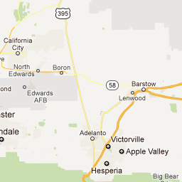  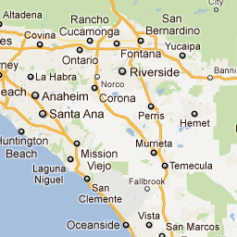  Map Data - Terms of Use | 14747 San Fernando Road  Sylmar, CA, 91342  Latitude: 34° 19.42' N  Longitude: 118° 30.18' W  FRS ID: 110033204887  NAICS Code: 562212

Total Facility Emissions in MT CO₂e  (excluding Biogenic CO₂) | 207,883
Emissions by Gas in MT CO₂e
Methane (CH₄) | 207,883
Emissions by Source/Process in MT CO₂e
(excluding Biogenic CO₂)
Landfills | 207,883
Landfill emissions estimated from modeled methane generation and other factors | 6,546
Landfill emissions estimated from methane recovery, destruction and other factors | 207,883
The greater of these two estimates is used as the facility's landfill emissions. Learn more about measuring emissions at landfills.
Information on Landfills
Is landfill open? | Y
Estimated year of closure (if open) | 2037
Does the landfill have an active gas collection system? | Y
Capacity of the landfill gas collection system (if used) | 12501

